CC3501 Weekly Report

**Group number:** 2 **Team members:** Ethan Waters, Lachlan Pryce  
**Week number:** 7

**Progress this week**

|  |  |  |  |  |
| --- | --- | --- | --- | --- |
| **Task** | **Who did it?** | **What were the outcomes?** | **Who did the peer review?** | **What did you learn?** |
| For IMU calibration - determine a method of accounting for internal magnetic disturbances. | Lachlan | Found a free use calibration tool “MotionCal” commonly used for low-end IMU calibration. |  | MotionCal software provides magnetic offset values if Magnetometer data is formatted correctly and read via COM port. |
| Test Hard & Soft Iron (HSI) calibration method using available 9DoF IMU. | Lachlan | Existing Arduino code for the IMU (MPU9250) was modified to print X, Y and Z magnetometer values in format accepted by MotionCal.  Software provided magnetic offset values (see Figure 1). |  | Magnetic offset values can be used in further calibration. Once calibrated sensor fusion algorithms can be applied. |
| Liaise with Joesef to pre-order some components. | Lachlan | IMU’s pre-orded. Awaiting response from JLCPCB in regard to lead time. |  | Just because JLCPCB says they have 300+ of the IMU you plan to use, doesn’t mean they’ll still have 300 two weeks later. |
| Complete half of PCB routing. | Lachlan | PCB design half complete. | Ethan | Routing doesn’t get any easier. |
| Complete PCB Routing | Ethan | Complete routing | Lachlan |  |
| Update Schematic to full hierarchical structure | Ethan | Correct schematic |  | Committing to an appropriate layout increases readability |
| Rearrange pin net names to reduce routing complexity | Ethan | Slightly reduces routing difficulty |  | Routing still difficult |
| Implement alternative ESP-32 chip with antenna and all components associated with it | Ethan | No longer require external crystal. | Lachlan |  |

**Overall project tracking:** [fill this in at the beginning of the project and update weekly based on actual progress]

|  |  |
| --- | --- |
| **Week number** | **Milestones** |
| 1 | Confirm project topic and begin |
| 2 |  |
| 3 | Arm can move with an input from a socket. The input is an automated test script executed by a client to mimic the embedded system output |
| 4 | Select components & review datasheets |
| 5 | Begin schematic |
| 6 | Complete Schematic, forward to Bronson for feedback. |
| 7 | Submit complete schematic to Bronson for feedback. Complete PCB design for feedback, |
| 8 | Submit board for manufacture start of the week. Work on Code. |
| 9 | Work on vision based movement with PI while waiting for embedded systems | Any other code that can be done before |
| LR |  |
| 10 |  |
| 11 |  |
| 12 |  |
| 13 | Demo day during Friday lab |

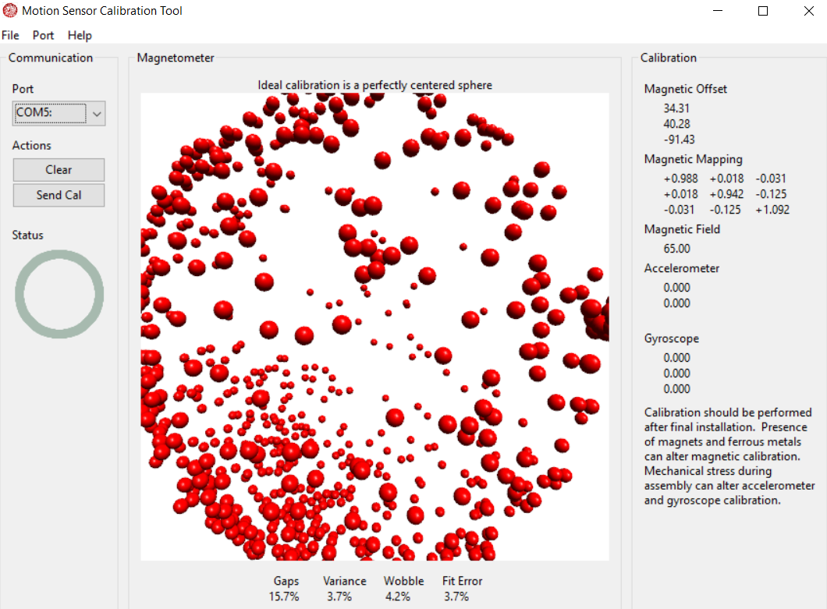

Figure 1: Magnetic offset values provided by MotionCal software. Calibration is achieved by manoeuvring IMU until enough data is recorded.